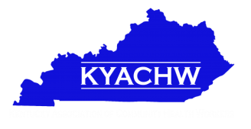
Kentucky Association for Community Health Workers
Board Meeting Agenda
March 22, 2018
10 AM
Montgomery County Health Department

Welcome and Introductions

- Bev Beckman

- Secretary Report
- Treasurer Report

Subcommittee Reports

- Evaluation and Outcomes
- Certification
- Website updates
- Conference Planning Update
- Membership
- Committee member/chair update

Tom Collins Grant
- Update

Dr. Jean Edwards Training Grant Opportunity
- LOS
- Grant summary

Bev Beckman Introduction – Louisville CHW Group

Medicaid Waiver Updates - Story Banking/Personal Testimonies/Blogs

Resources, Requests, and Sharing
- Update on Kathy Bathje’s donation support
- New Brochure Order
- Bannerstand/Marketing items

Marketing/Sponsorships
- Social Media updates
- Membership Drive

Next Board Meeting
- Next association meeting date/time

