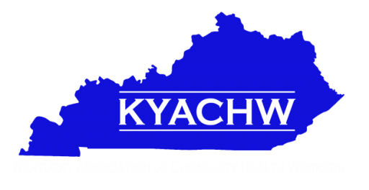
Kentucky Association for Community Health Workers
Association Meeting Agenda
March 22, 2018
11AM – 3 PM
Montgomery County Health Department

• Welcome and Introductions

• Secretary Report
• Treasurer Report

• Tom Collins Grant Update
• Dr. Jean Edwards Training Grant Opportunity
o LOS
o Grant summary

• Bev Beckman Introduction – Louisville CHW Group

• Committee Chair updates

• 12 PM - LUNCH

• 1-3 PM Guest Speaker Presentation –

o Liz Edghill - Family Health Centers in Louisville
o Emily Beauregard - Kentucky Voices for Health

• New Business
• Old Business

• Adjourn

